**SAIP Promoting Physics Education**

**for Socio-Economic Development of South Africa**

**Introduction**

The SAIP’s current main strategic focus is to improve the physics education pipeline through various initiatives with the following goals;

* Addressing the challenges of human capital in the National System if Innovation (NSI) both qualitatively (**rates of knowledge production**) and quantitatively (**number of PhDs produced**).
* **Building the SET human capital pipe line** by including disadvantaged communities in physics and making resources available to both learners and educators hence universities and colleges will have a greater pool of students from which SET student can be drawn
* Contribute to **societal transformation** by expanding the numbers of **scientists from previously disadvantaged** communities
* Contribute to societal transformation by **expanding the numbers of women and girls in science and technology,**
* Better quality teaching will lead to **better quality students hence increased PhD throughput.**

The SAIP projects are already bearing fruit and having an impact as shown by results, for example, from the teacher development project and the SA Physics Olympiad.

**Background**

It is recognised worldwide that physics is a basic science, critical to the development of humanity through broadening our understanding of the world we live in and the universe. In particular, physics often acts as a lead science such that the fundamental physics research of today is the technology of tomorrow. Thus, physics remains the most fundamental basic science underpinning other science and technology disciplines. For example, engineers, biomedical scientists, medical professionals and computer scientists, require a background of physics. Hence if South Africa needs to grow the pool of Science Engineering and Technology (SET) manpower we need to develop a big pool of high school learners with a background in physics. Figure 1 below summarises some of the key science and technology fields whose success depends on physics.

Physics as a fundamental basic science is central to South Africa’s ability to build the SET Human Capital pool of skills required for strategic initiatives such as the National Development Plan (NDP), Industrial Policy Action Plan (IPAP), Strategic Infrastructure Projects (SIPs), DST National Innovation Strategy, Basic Sciences Framework and key projects such as Nanotechnology Initiative and Square Kilometre Array (SKA).

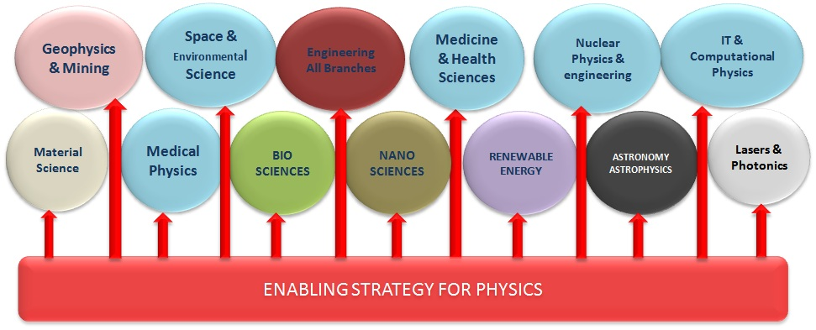

**Figure1: Physics Education Underpinning Science & Technology Disciplines**

**Why Education Pipeline Support by SAIP**

The last decade has seen dramatic improvements in the Science System for South Africa, for example award of the SKA to South Africa. However the SAIP realises that **The main threat to the sustainability of this positive trend is physics education pipeline.** This is now the most crucial point to be addressed by SAIP. Hence one of the medium to long to long-term strategic focus area is to **improve the physics educational pipeline** from high school, to undergraduate, and through to post-graduate level. The aim is to ensure that large numbers of **high quality, competent, well-educated graduates** coming into the system achieve the necessary five-fold increase in PhDs, and hence result in a sustained growth of the discipline.

**Figure 2: Physics Education Pipeline & SAIP Interventions**

For global competitiveness, and to meet the aspirations of young people, we need well-qualified professionals who know their subject. Therefore, we need post-graduates with opportunities opening for them; therefore, the BSc must provide a sound base, and therefore, we cannot ignore the quality of physics teaching and learning at schools.

**KEY SAIP Projects / Activities Supporting the Education Pipeline**

The key SAIP projects and activities supporting physics education are summarised below and in the attached supporting documents. In a nut shell the SAIP key projects supporting physics education have the following impact

**Strategy on Improving Physics**

After realising the challenges regarding the poor quality of entering students coupled with poor quality and low throughput in undergraduate physics, the SAIP established a consultative project to address physics education in South Africa. This project will address the challenges of human capital in the NSI both qualitatively (rates of knowledge production) and quantitatively (number of PhDs produced). The overall goal of this strategy is to strengthen the Physics Educational Pipeline to contribute to the socio-economic and technological development of South Africa. Better quality undergraduate teaching will lead to better quality students hence increased Ph.D. throughput.

**Teacher Development Projects ( See attached Teacher Development Project Flyer for more details)**

One of the goals underpinning physics education improvement strategy is the enhancement of the professional competence of physical science teachers. In 2012 the SAIP started a project on physics teacher development. This project emanated from the fact that physics is the most dreaded subject by teachers, students and parents. However, for one to be trained in any SET discipline they must have passed physics at high school. Hence if we need to increase the number of students who can be trained in SET disciplines we must increase the pass rate of physics at high school.

This project focuses on the development of skills of teachers in Mathematics and Physical Sciences hence contribute to better teaching skills leading to high pass rates in sciences and an increase in Human Capital with Science, Engineering and Technology (SET) skills required for key government initiatives such as the Square Kilometre Array (SKA), National Development Plan (NDP) and the Strategic Integrated Projects (SIPs).

The project provides both in-service and pre-service training opportunities in order to holistically and adequately address teacher professional development needs. The project will achieve the following;

1. Produce

* A series of secondary school physics educational support materials,
* Physics Teaching Methodology Manual
* Physics experiments and/or demonstration materials.
* Trainers / Instructors on Physics teacher development
* Physics related career information.

1. Historically disadvantaged schools will

* Receive quality physics tuition,
* Access supplementary physics print, electronic and experimental resources
* Perform laboratory investigations required by the national curriculum
* Link clasroom science to pratical aspects in the SA economy

1. Teachers from historically disadvantaged schools, townships, rural and farm schools will;

* Receive training on teaching physics hence improve their skills in delivering physical science.
* Develop improved competency and confidence hence increase student pass rates and attract more students into physics
* Acquire laboratory skills

1. Increased Teacher Competency will result in higher pass rates hence an increase in the pool of learners with physics background who can be trained in various Science, Engineering and Technology disciplines

The SAIP is currently engaging various stakeholders to plan expansion of the project to Limpopo Western Cape and Eastern Cape Provinces. SAIP targets that by end of 2017 the teacher development projects will have a presence in four provinces, Gauteng, Limpopo, Western Cape and Eastern Cape.

The Teacher Development Project attracted a visit by his Royal Highness, Prince Edward, the Earl of Wessex on 23rd May 2016



**His Royal Highness, Prince Edward, the Earl of Wessex visiting the SAIP Teacher Development Project At UJ - SCC**

**Project Multiplier Effect:**

This teacher development project will have multiplier effect through two areas

1. **Train the trainers’ course** – At the beginning of each year the project trains Physics Teacher Development Trainers. These trainers are empowered to train more teachers in physical science. As the project grows we target to train trainers for every science centre in the country so that they can train teachers in their respective regions.
2. **Teacher Training** - The projects tartegs to train teachers through a weekly Friday afternoon programme and holiday one week workshops. Here the chain reaction is the number of students that benefit from teachers new found knowledge and enthusiasm. For example 50 teachers trained with an average class size of 25, the multiplier effect is 1250 students, of multiple grade levels, enjoying physical science and passing with better grades.

On the 7th of September, the Teacher Development Project was recognised and won best managed and impactful project in the category of Science and Innovation by the British High Commission



**SAPhO (South African Physics Olympiad)**

The primary aim of SAPhO is to identify, nurture and monitor young people in South Africa with an above average ability in Physics, and if successful, to try and assist them finding placement in SA’s Tertiary institutions. The South African Agency for Science and Technology Advancement, SAASTA, hosts the South African National Science Olympiad, SANYSO. There is a collaborative arrangement between the SAIP and SAASTA which enables SAPhO candidates to be selected from SANYSO. Additional candidates are selected from other Olympiads and competitions from around South Africa.

The top three candidates will receive Gold, Silver or Bronze Certificates along with other prizes. Others, depending on their marks, will receive Merit Certificates, Honourable Mentions or Participation Certificates.

SAPhO is already contributing promoting SET skills as exemplified by SAPhO 2016 and SAPhO2015 winners. For SAPhO 2015/16, our Gold and Silver Awards winners, achieved the following in their final matric results:

* Mr Conrad Strydom (2016 Gold Award winner) Hermanus High in the Western Cape become South Africa’s top achiever in the Matric Class of 2016, and he is going to study Physics at the University of Stellenbosch
* Mr. Logan Geldenhuys (2015 Gold Award winner) from St John’s College in Johannesburg passed with 10 distinctions out of the 12 subjects Logan Geldenhuys took in his matric.
* Mr. Hamandishe Mathivha (Silver Award winner) from Mbilwi Secondary School in Sibasa, Thohoyandou was named South Africa’s top maths and physical science matric pupil of 2015. Mathivha was also Limpopo’s second-best pupil for 2015.

**Online Teaching and Learning Platform**

Another challenged observed in the provision of quality science education is the shortahge of materials and skilled manpower. In order to address the shortage of resources such as teaching materials, laboratory facilities and qualified teaching staff in physics , the SAIP is developing a National Online Physics Teaching & Learning Platform OPTLP that will facilitate the sharing of quality and scare resources.

1. This Implementation is underpinned by the Chapter 8 of the DHET Green Paper : Open and Distance Learning: Flexible and Innovative Modes of Delivery
   1. Section 8.1.2 Shared Learning and Support Centres
   2. Section 8.2 Improved Access to and Use of Appropriate Technology
   3. Section 8.3 Collaborative Development of High Quality Learning Resources
2. A shared development of core teaching material will ensure and promote student mobility, in line with initiatives like the Bologna Protocol in Europe.
3. More extensive libraries of problems, solutions, papers etc. will assist the students in their studies, and will assist younger lecturers to develop their portfolios. They will have more time to concentrate on the development of excellent teaching methods and research, as the development of tutorials and exams can be very time consuming.
4. The barrier of participation in a new core area will be lowered, eg, Astro, Nano, Nuclear, Particle, etc. This will promote the raising of standards.

**Outreach and Public Understanding of Physics**

The value of this project is underlined by the fact that the public and industry and commerce still have vague understanding of the role physics plays in economic development, science and technology advancement. Perception of physics as a career option is not very well supported because parents and guardians do not understand the job prospectus if one studied physics. School pupils and teachers still consider physics to be difficult subject hence it has slow uptake and interest.

SAIP has engaged in a lot of outreach events by attending events organised by DST and other institutions .

Please see attached reports

