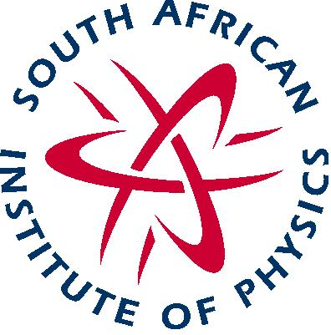 | South African Institute of Physics  NPO Registration Number: 130-172 NPO  SAQA Professional Body ID: 777  http://www.saip.org.za/  Postnet Suite 165, Private Bag X025, LYNNWOOD RIDGE, 0040, South Africa

Prof. A. Muronga (President)
Nelson Mandela Metropolitan University - Tel: +27 (0) 41 504 2873 Email: azwinndini.muronga@nmmu.ac.za
Prof. M. Chithambo (Honorary Secretary)
Rhodes University Tel: +27 (0)46 603 8450 Email: m.chithambo@ru.ac.za

Mr. B. Masara (Executive Officer)
Tel: +27 (0) 12 8412627Fax: +27 86 605 0871 Email: brian.masara@saip.org.za

Media Release
Learners excel in Physics

On Wednesday, 31August, 2016 the South African Institute of Physics (SAIP) will announce the South African Physics Olympiad (SAPhO) results to the media, the schools involved and the learners who excelled in the SAPhO exam.

Over a hundred learners from 46 schools were selected from nearly 19 000 learners who wrote the SA National Youth Science Olympiad (SANYSO) to write SAPhO 2016 exam.

”South Africa, like every other country in the world, has amongst its youth, a latent talent that needs to be identified, nurtured and monitored, to allow them to reach their full potential”, says Case Rijsdijk, SAPhO Convener. “There are talent scouts for potential sports men and women, why not for maths and sciences? After all our future lies in education and a technologically based economy. Identifying future scientists and engineers is essential and SAPhO is one pathway to success.”

These results were most satisfactory with an average mark of 46% for SAPhO. The range of marks was 75% and 16%. Learners, who do well in any other recognized science competition or Olympiad, can be invited to take part in SAPhO 2017 which will be held on Monday, 7 August, 2017. The organisers hope to increase the SAPhO footprint by attracting closer to 200 learners to participate in the Olympiad next year.

Conrad Strydom, a grade 12 learner from Hermanus High School in the coastal resort of Hermanus, Western Cape, was the top scoring learner in this years Olympiad with a score of 75%. He will receive a Gold Certificate, R1 500 and the SAIP Medal, which will be presented to him at the Annual SAIP Conference dinner in Stellenbosch in July 2017.

His teacher Charlotte Rabie said that “Conrad has been a focused, dedicated learner with a wide general knowledge, and that the school was proud of his achievement”. Conrad added that "To me physics has been a way to understand the Universe and my place in it. I believe this understanding can be used to push the limits of what is possible, thereby ensuring a better future. I would also like to thank all past educators for the role they have played in shaping my understanding".

In second place was Ahmed Dhansay, a grade 12 learner from Bishops, in Rondebosch, Cape Town, with a score of 73%. He will receive a silver Certificate and cash prize of R1 000. Ahmed commented, “I feel honoured to get this award, and owe thanks to my family for their continued support, my science teacher, Mr Ledwidge, for sacrificing his free time whenever I needed help, and, of course, to SAPhO for giving me the opportunity to further my physics knowledge”.

David Broodryk, a grade 12 learner from Westerford High School in Rondebosch, Cape Town, who with 72% scooped third place, he will receive R500 cash and Bronze Certificate. His reaction to hearing of his result was “As someone who is involved primarily in maths Olympiads, I am very excited about doing well in the physics Olympiad and continuing the long line of individuals lucky enough to excel at both”.

SAPhO will also award those who scored between 71% and 61% Merit Certificates for their achievements and those who scored between 59% and 50% will receive Honourable Mention Certificates the remaining learners will receive Participation Certificates to acknowledge their participation in the Olympiad.

The SAPhO Convener, Case Rijsdijk, has said that he is grateful to the Department of Science and Technology and the South African Agency for Science and Technology Advancement for their support and funding. In addition he also voiced his thanks to the SAIP Executive Officer, Brian Masara, and the Project manager, Ndanganeni Mahani for all their efforts in making SAPhO a success.

SAPhO is hosted by the South African Institute of Physics (SAIP) with the aim of identifying young southern Africans with ability in Physics, in the hope that these students will continue to study Physics at tertiary institutions and Universities within South Africa.

SAIP is the voice for Physics in South Africa. It is a professional body for practising physicists in a variety of disciplines ranging from Cosmology to Medical Physics. It has several goals, one of which is raising the awareness of Physics and its importance to our daily lives; much of which can be achieved through education.

Ends
For further enquiries contact:

Case Rijsdijk
SAPhO Convener
particles@mweb.co.za
case@saao.ac.za
044 877 1180
083 444 2494

